**NAME:** Enoghayin Osarobo

**SCHOOL ID:** ALT/SOE/024/2948

**TRACK:** Cybersecurity

**Snort Hands-On Practical**

1. **Snort Overview:** Below is the screenshot of the Snort overview, all tasks (Task 1–11) as completed (each with a checkmark).

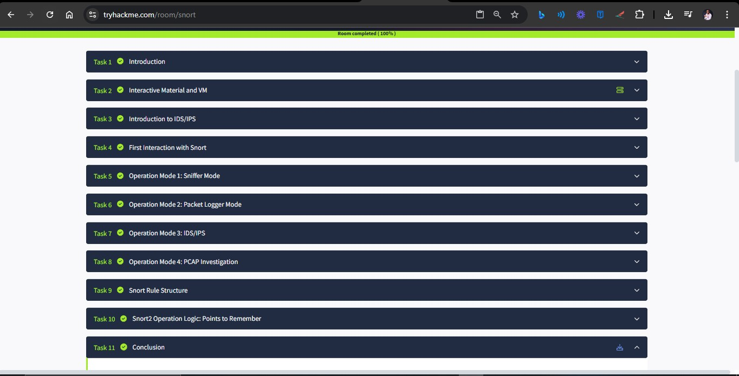

1. **Congratulations Page:** The congratulations message after I was done with the 11 tasks; Screenshot as show below*.*

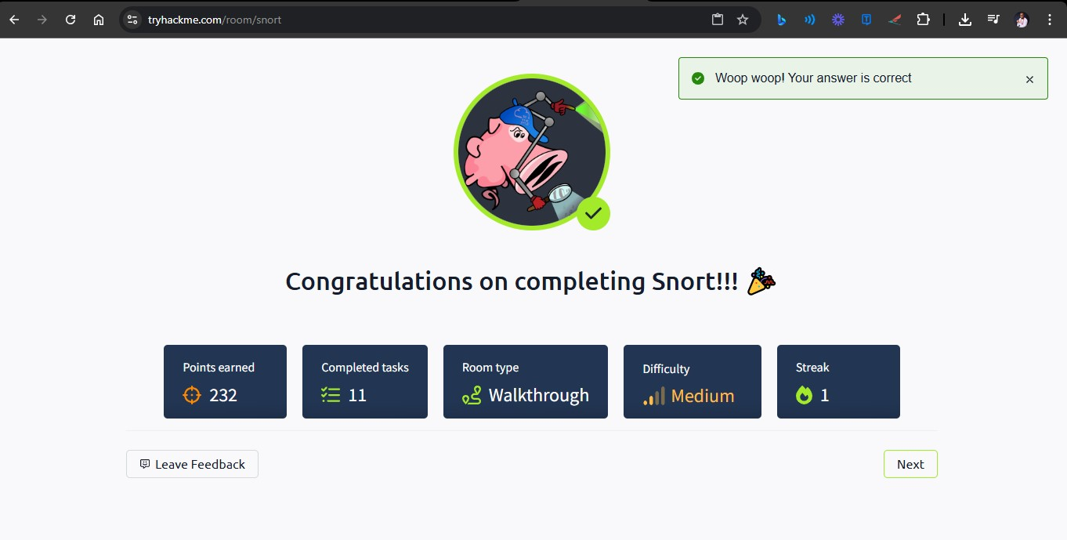

1. **Special Instruction:** New file named with my AltSchool ID created in the directory Task-6 as show below.

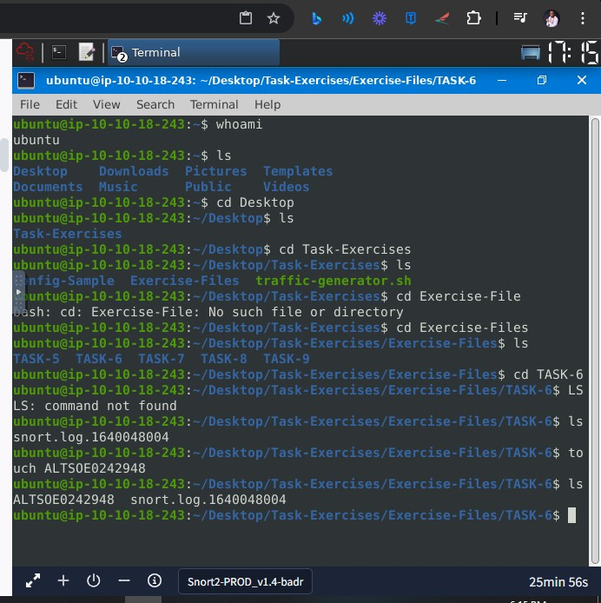

1. *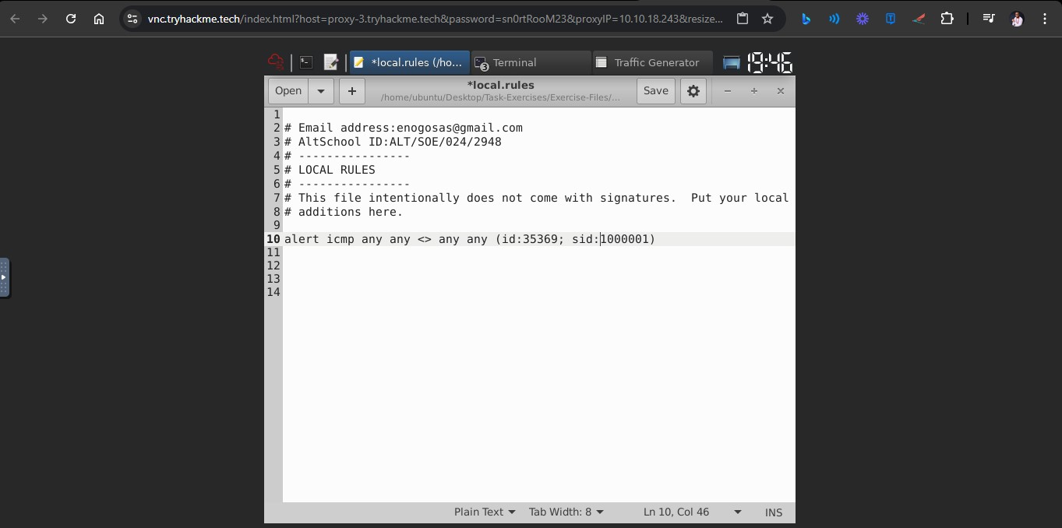***Configuration Tasks:** From task 9; the **local.rules** file in the Snort configuration directory showing my details as comments at the top of the file. *See screenshot below:*